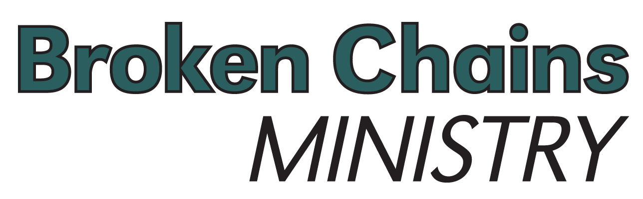
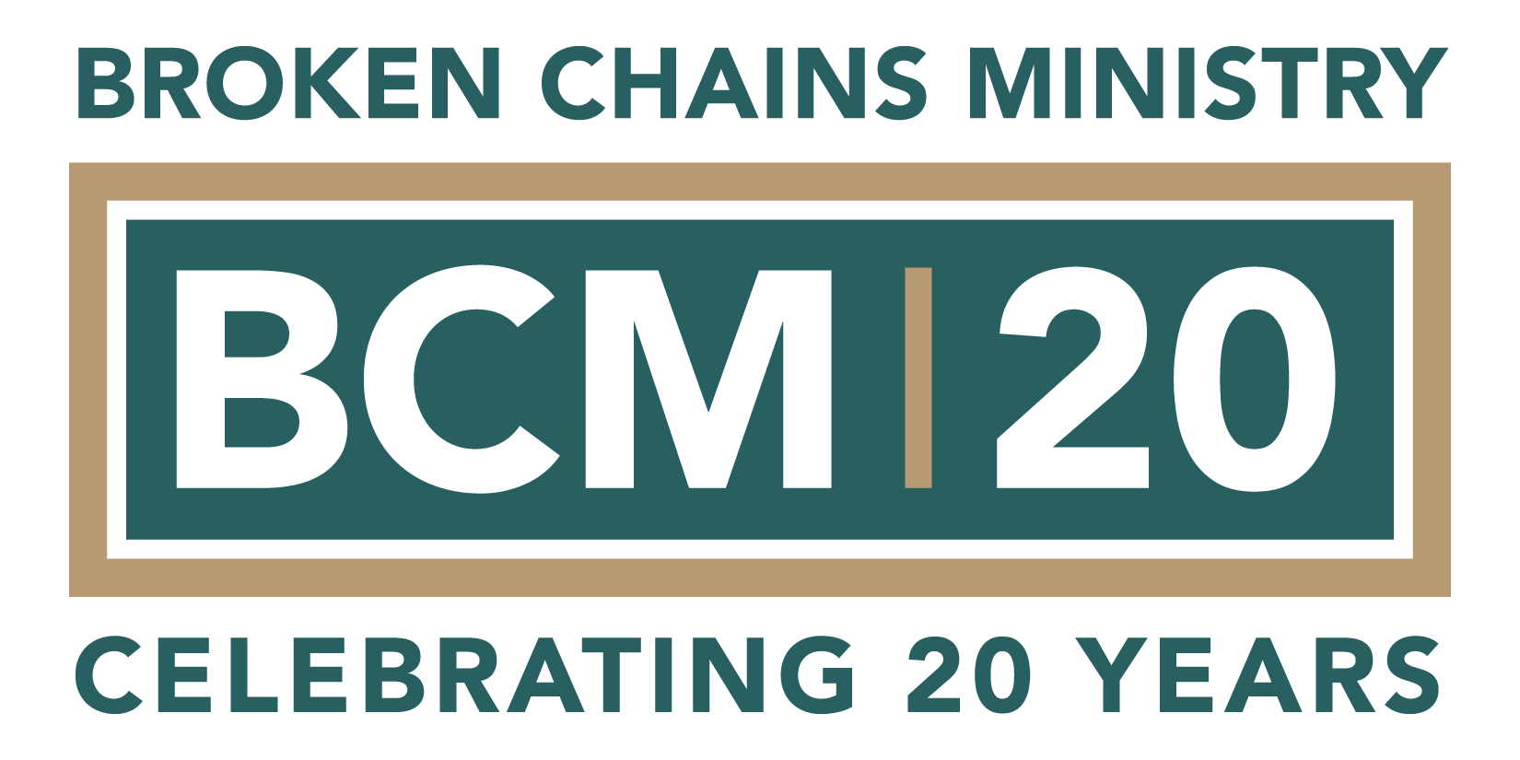

Broken Chains Ministry Enters 20th Year
Exceeds $6.75 Million in Economic Impact

Akron, Ohio – June 8, 2023 – Founded by executive director Dennis Shawhan, Broken Chains Ministry has been a successful example of Restorative Justice in Summit County since 2004.

“One in six people in Ohio have a felony history and about 2,000 people return to the Akron area from incarceration each year,” Shawhan explained. “Our clients face many barriers to successful reentry and recovery, and our programs were developed to help overcome them.”

What started as a jail and prison ministry in 2004 has expanded to include a full-service café and workforce development program as well as a certified women’s recovery home. These Restorative Justice programs emphasize community collaboration, support services, identity restoration, accountability, and restitution.

Launched in 2011 and located in Akron’s Robert K. Pfaff Metro Transit Center, Urbean Café has contributed more than $6.75 million in economic impact and helped more than 135 formerly-incarcerated citizens achieve independence and make restitution. The Café has a two percent or lower recidivism rate compared to the national average of about 66 percent, which has saved Ohio taxpayers about $3 million in direct costs.

Lydia’s Home, a Certified Level III Recovery Residence in the City of Green opened in 2017, offers a unique curriculum-based program for women.

“Lydia’s Home presented an opportunity to collaborate with the City of Green including the Mayor’s office and the Opioid Task Force,” said Shawhan. “When we purchased a home in a suburban area, we wanted officials and community members to be confident in our commitment to being good neighbors. By renovating the home, restoring the property, and welcoming visitors, we have built community trust while serving women in recovery.”

This approach requires collaboration with established systems of care and community members and aligns with the recommendations of the Ohio Council of Behavioral Health, Family Services Providers, and the Center for Social Innovation.

The Ministry will celebrate its success with a public event in October.

About Broken Chains Ministry
Founded by Rev. Dennis Shawhan, Broken Chains Ministry is a reputable 501(c)(3) nonprofit organization in Summit County that has earned the coveted GuideStar Platinum Seal of Transparency. Its mission is to improve public safety and support the local economy by reducing recidivism and restoring individuals to the community through Restorative Justice programs. www.brokenchainsministry.org

